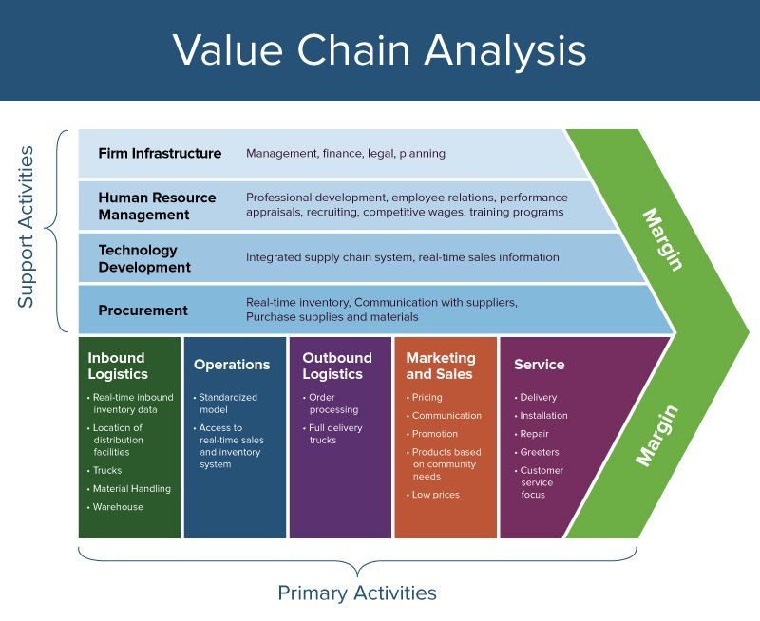

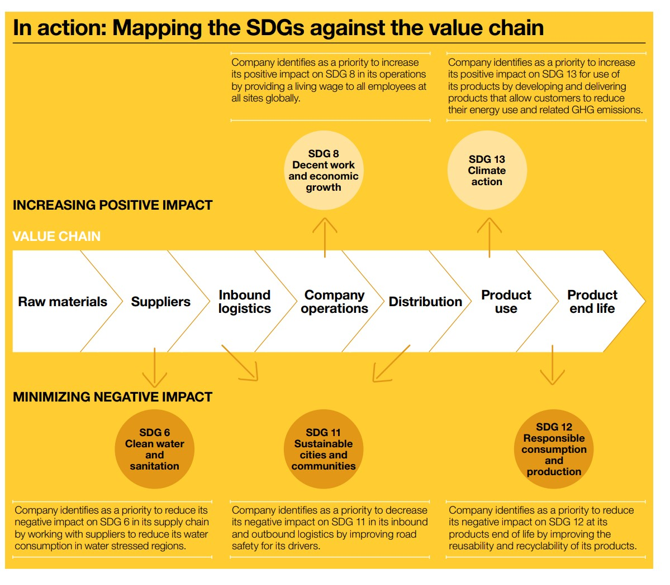

Your Company’s Value Chain

Increasing positive impact

Minimizing negative impact